Requisition Letter

From
JAYANTHI PRIYA A
Guest Lecturer,
Department of Computer Applications,
Government Arts and Science College,
Sathyamangalam- 638401

To
The Controller of Examinations,
KSR College of Arts and Science College (Autonomous),
Tiruchengode.

Respected Madam,
Sub: Requisition for panel of examiner – reg.
Presently I am working as a Guest Lecturer, Department of Computer Applications, Government Arts and Science College, Sathyamangalam. I request you to consider my resume and include me as a panel of examiner for Practical Examinations and Paper Evaluation of End Semester Examinations in your esteemed Autonomous Institution. I assure you that I will keep all the appointment provided me as confidential one.
I have enclosed a copy of resume for your kind reference.
Thank you,
Place: Sathyamangalam
Date : 30.09.2024 Yours faithfully,
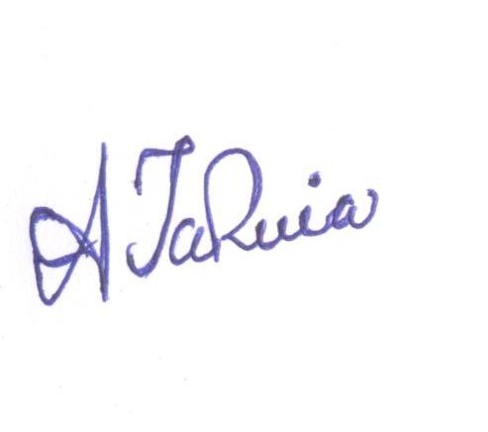
( JAYANTHI PRIYA A)

RESUME
I. Personal Information:
Name | : | JAYANTHI PRIYA A
Designation | : | Guest Lecturer,
Department | : | Computer Applications
College |  | Government Arts and Science College, Sathyamangalam-638401
Area of Specialization | : | Data structure,Computer Network,
Date of Birth & Sex | : | 28-01-1987 & Female
Address for Communication

Residential Address | Office Address
13A Kavitha Garden  Gobichettipalayam  Erode-638476 | Guest Lecturer,  Department of Computer Applications  Government Arts and Science College, Sathyamangalam-638401
Mobile:9677402456, | E.mail: jayaaru28@gmail.com
II. Educational Qualification:
Degree | Major | College Name & University | Month& Year  of  Passing | Percentage of  Marks/Grade
B.Sc | Computer Science | Vysya College of Arts and Science -PeriyaUniversity, Salem | April 2008 | 68-First
M.C.A | Computer Applications | Periyar University, Salem | April 2011 | 79-D
SET | Computer Science and Applications | UGC | SEP 2017

III. Professional Experience

S.  No | Position | Organization | Period |  | Experience
S.  No | Position | Organization | From | To | Year | Month
1 | Lecturer | Government Arts And Science College, Sathyamangalam | 01.06.2018 | 08.02.2023 | 5 | 2
2 | Guest Lecturer | Government Arts And Science College for Women, Karimangalam, Dharmapuri | 09.03.2023 | 22.06.2023 | 0 | 4
3 | Guest Lecturer | Government Arts and Science College, Sathyamangalam. | 23.06.2023 | Till Date | 1 | 3
Total |  |  |  |  | 6 | 9

IV. Papers Presented: 2 (National Level - 2)
VI. Work Shop and Seminar Attended: 5

VIII. Subjects Taught
1. C,C++,Java, VB,VC++, .NET Programming  2. Database Management Systems  3. Data Mining & Data Warehousing  4. Object Oriented Analysis and Design  5. Computer Graphics and multimedia  6. Software Project Management  7. Fundamentals of Digital Principles  8. Microprocessor  9. Data Structures  10. Operating Systems  11. Computer Networks  12. Software Engineering & Testing | 13. Web Technology  14. Open Source Programming  15. Information Technology  16. E-Commerce & E-Business  17. Big Data Analytics  18. Cryptography and N/W Security  19. Compiler Design  20. Cloud Computing  21. Mobile Application development  22. Wireless Networks  23.Client/Server Computing  24. Internet of Things

I hereby declared that the above mentioned details are true to my knowledge.

Place: Sathyamangalam
Date: 30.09.2024
(JAYANTHI PRIYA)

